Lesson 04 Demo 06

Configuring Autoscaling

Objective: To configure autoscaling on a VM scale set for automatically adjusting the instance count

Tools required: None

Prerequisites: A running Virtual machine scale set

Steps to be followed:
- Configure Autoscaling on the VM scale set

Step 1: Configure Autoscaling on the VM scale set

  - Open the Azure portal and select the resource group that contains your scale set

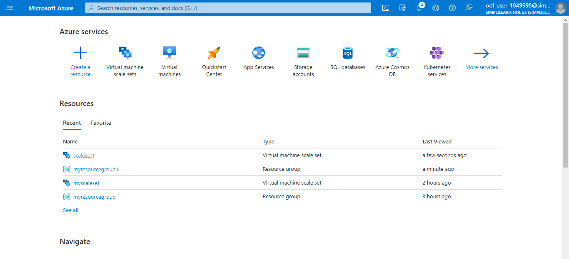

  - Choose Scaling from the menu on the left-hand side of the scale set window
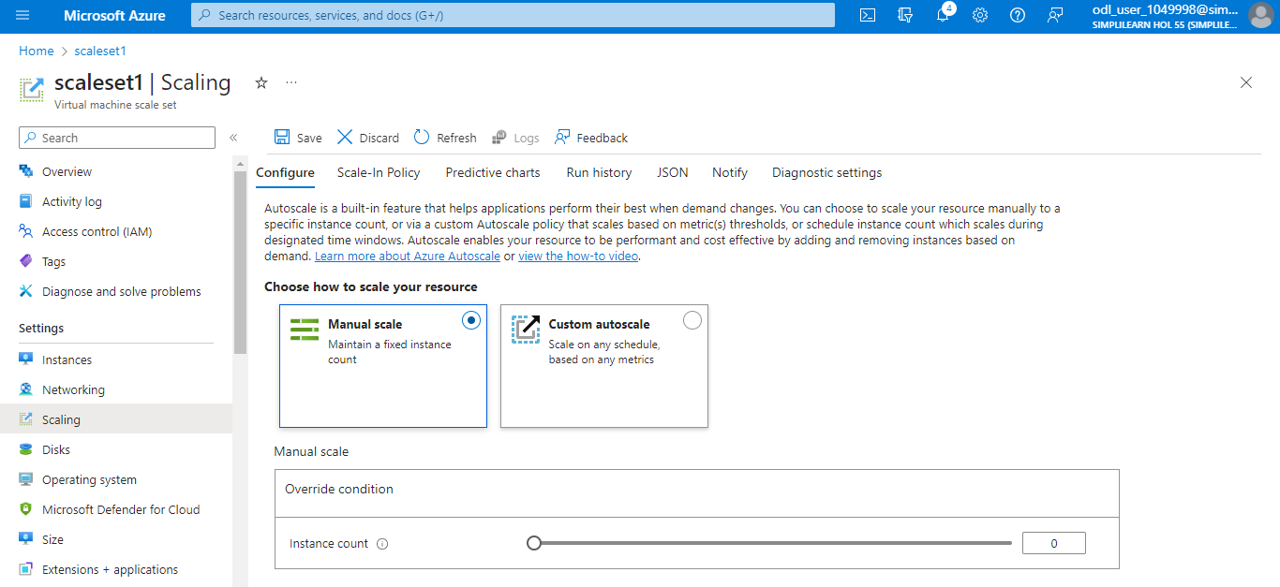

1.4 Enter a name for your settings and select the option Custom autoscale
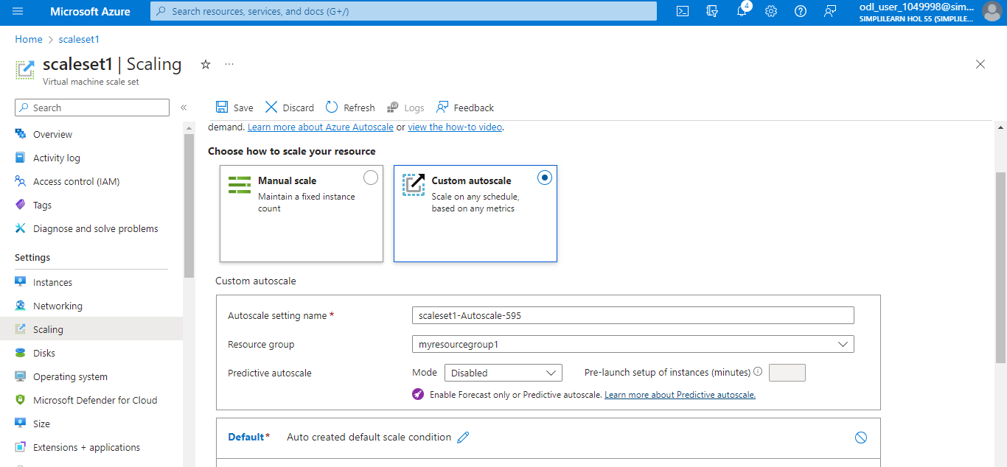

  - Now, create a rule that increases the number of VM instances in a scale set when the average CPU load exceeds 70% over 10 minutes. When the rule triggers, the number of VM instances is increased by 20%. In scale sets with a few VM instances, you can set the operation to increase the count and then specify 1 or 2 for the Instance count. In scale sets with many VM instances, an increase of 10% or 20% may be more appropriate.

  - Click on + Add a scale condition

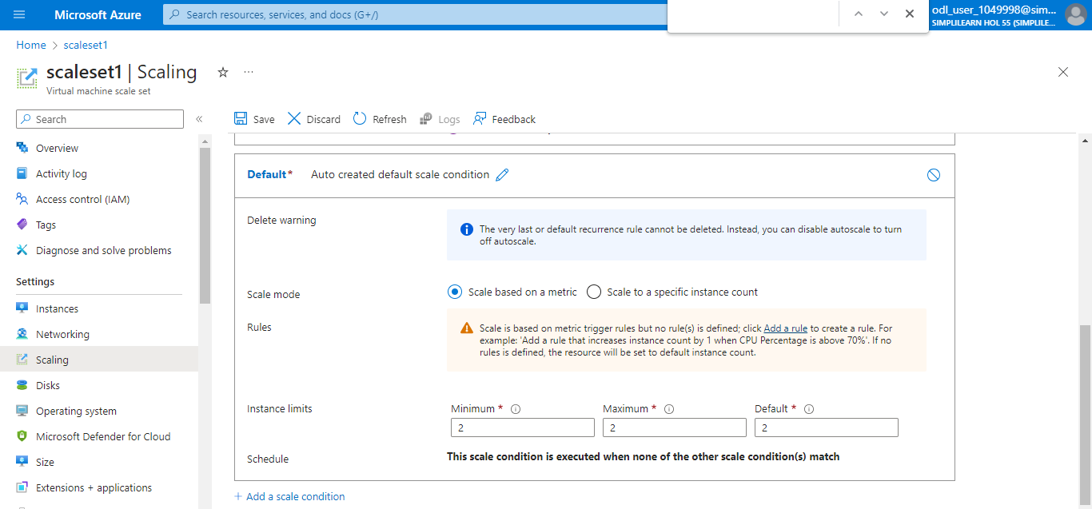

  - Click on Save

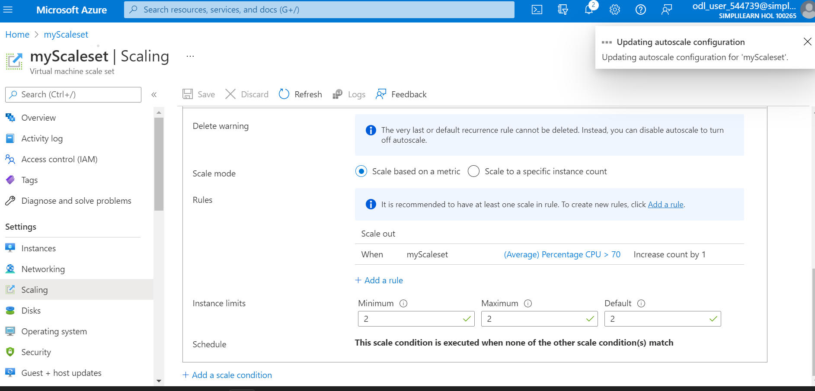

The following message will appear after saving:

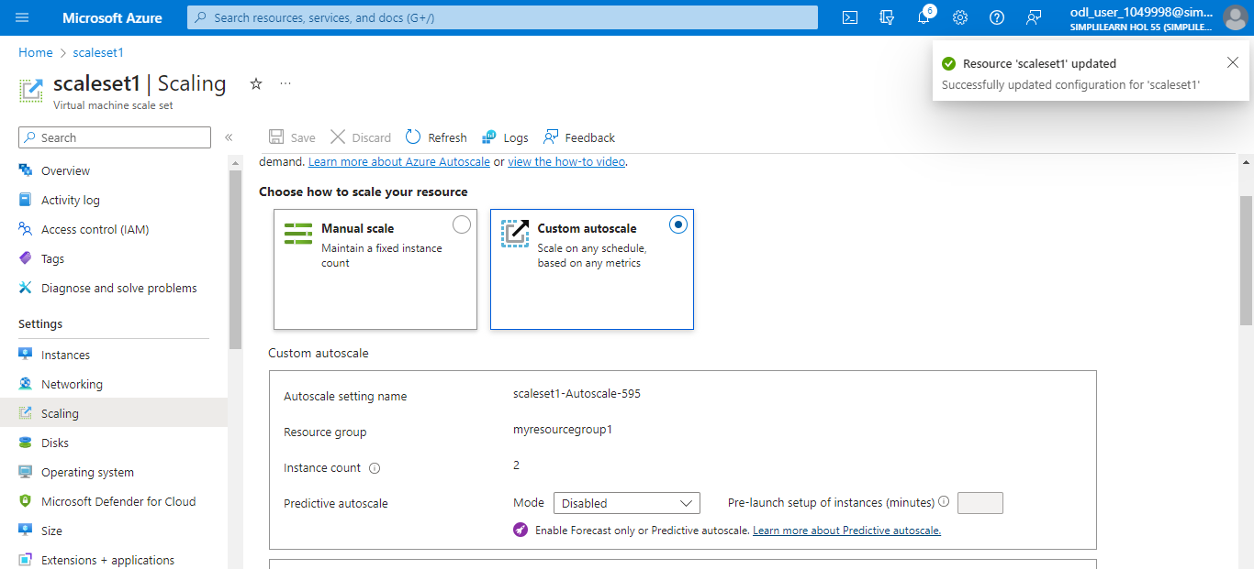

You have now successfully configured autoscaling on a Virtual machine scale set to automatically adjust the instance count based on the load.

